JAVA DA 3

* Q. Design the Java Web Application using either JSP/Servlets to perform the following operations
  1. Create the above said tables by creating Servlets
  2. Insert the records into the above tables by creating a separate Servlets.
  3. Delete the specified record into the above tables by creating a separate Servlets
  4. Update the specified record into the above tables by creating a separate servlets
  5. Display the list of employees located in the specified company.

**CODE:**

//FOR COMPANIES

Comp.java

**public** **class** Comp {

**private** **int** cid;

**private** String name,city;

Comp(){

}

**public** **void** set_para(**int** cid, String name, String city) {

**this**.name=name;

**this**.city=city;

**this**.cid=cid;

}

}

Comp sql

import java.sql.*;

import com.mysql.cj.jdbc.Driver;

class xyz_sql {

public int reg_company (Comp comp) {

final String DB_URL = "jdbc:mysql://localhost:3306/xyz";

final String USER = "root";

final String PASS = "";

try {

Class.forName("com.mysql.cj.jdbc.Driver");

Connection con = DriverManager.getConnection(DB_URL, USER, PASS);

Statement stmt = con.createStatement();

stmt.executeUpdate("insert into company (name,cid,city)values(name,cid,city)");

con.close();

} catch (Exception e) {

System.out.println(e.toString());

}

return 0;

}

}

Comp servlet

import java.io.IOException;

import javax.servlet.annotation.WebServlet;

import javax.servlet.http.HttpServlet;

import javax.servlet.http.HttpServletRequest;

import javax.servlet.http.HttpServletResponse;

@WebServlet("/xyz_ltd")

public class xyz_ltd extends HttpServlet {

private static final long serialVersionUID = 1L;

public void service(HttpServletRequest req, HttpServletResponse res) throws IOException {

String name = req.getParameter("name");

int cid = Integer.parseInt(req.getParameter("cid"));

String city = req.getParameter("city");

res.getWriter().println(name + "\n" + city + "\n" + cid);

Comp comp= new Comp();

comp.set_para(cid, name,city);

xyz_sql x= new xyz_sql();

x.reg_company(comp);

}

}

//FOR EMPLOYEES

Emp.java

**public** **class** Emp {

**private** **int** eid, cid2,sal;

**private** String name2, dept_name, desig;

Emp(){

}

**public** **void** set_para(**int** eid,**int** cid2,String desig,**int** sal, String name2, String dept_name) {

**this**.eid=eid;

**this**.cid2=cid2;

**this**.name2=name2;

**this**.dept_name=dept_name;

**this**.desig=desig;

**this**.sal=sal;

}

}

Emp sql

**import** java.sql.*;

**import** com.mysql.cj.jdbc.Driver;

**class** emp_sql {

**public** **int** emp_company (Emp emp) {

**final** String DB_URL = "jdbc:mysql://localhost:3306/xyz";

**final** String USER = "root";

**final** String PASS = "";

**try** {

Class.*forName*("com.mysql.cj.jdbc.Driver");

Connection con = DriverManager.*getConnection*(DB_URL, USER, PASS);

Statement stmt = con.createStatement();

stmt.executeUpdate("insert into employees (eid,cid,desig,sal,name,dept_name)values(eid,cid2,desig,sal,name2,dept_name)");

con.close();

} **catch** (Exception e) {

System.***out***.println(e.toString());

}

**return** 0;

}

}

Emp Servlet

**import** java.io.IOException;

**import** javax.servlet.annotation.WebServlet;

**import** javax.servlet.http.HttpServlet;

**import** javax.servlet.http.HttpServletRequest;

**import** javax.servlet.http.HttpServletResponse;

@WebServlet("/emp_ltd")

**public** **class** emp_ltd **extends** HttpServlet {

**private** **static** **final** **long** ***serialVersionUID*** = 1L;

**public** **void** service(HttpServletRequest req, HttpServletResponse res) **throws** IOException {

String name2 = req.getParameter("name2");

String desig = req.getParameter("desig");

String dept_name = req.getParameter("dept_name");

**int** cid2 = Integer.*parseInt*(req.getParameter("cid2"));

**int** sal = Integer.*parseInt*(req.getParameter("sal"));

**int** eid = Integer.*parseInt*(req.getParameter("eid"));

//res.getWriter().println(name + "\n" + city + "\n" + cid);

Emp emp= **new** Emp();

emp.set_para(eid,cid2,desig,sal,name2,dept_name);

emp_sql x= **new** emp_sql();

x.emp_company(emp);

}

}

//FOR MANAGERS

Managers.java

**public** **class** Managers {

**private** **int** ind_proj, out_proj, mid,cid3;

**private** String name3;

Managers(){

}

**public** **void** set_para(**int** ind_proj, **int** out_proj, **int** mid,String name3, **int** cid3) {

**this**.ind_proj= ind_proj;

**this**.mid=mid;

**this**.cid3=cid3;

**this**.name3=name3;

**this**.out_proj=out_proj;

}

}

Manager sql

**import** java.sql.*;

**import** com.mysql.cj.jdbc.Driver;

**class** man_sql {

**public** **int** man_company (Managers manager) {

**final** String DB_URL = "jdbc:mysql://localhost:3306/xyz";

**final** String USER = "root";

**final** String PASS = "";

**try** {

Class.*forName*("com.mysql.cj.jdbc.Driver");

Connection con = DriverManager.*getConnection*(DB_URL, USER, PASS);

Statement stmt = con.createStatement();

stmt.executeUpdate("insert into managers (name,cid,mid,out_proj,ind_proj)values(name3,cid3,out_proj,ind_proj)");

con.close();

} **catch** (Exception e) {

System.***out***.println(e.toString());

}

**return** 0;

}

}

Manager servlet

**import** java.io.IOException;

**import** javax.servlet.annotation.WebServlet;

**import** javax.servlet.http.HttpServlet;

**import** javax.servlet.http.HttpServletRequest;

**import** javax.servlet.http.HttpServletResponse;

@WebServlet("/manage_ltd")

**public** **class** manage_ltd **extends** HttpServlet {

**private** **static** **final** **long** ***serialVersionUID*** = 1L;

**public** **void** service(HttpServletRequest req, HttpServletResponse res) **throws** IOException {

String name3 = req.getParameter("name3");

**int** cid3 = Integer.*parseInt*(req.getParameter("cid3"));

**int** ind_proj = Integer.*parseInt*(req.getParameter("ind_proj"));

**int** out_proj = Integer.*parseInt*(req.getParameter("out_proj"));

**int** mid = Integer.*parseInt*(req.getParameter("mid"));

//res.getWriter().println(name + "\n" + city + "\n" + cid);

Managers managers= **new** Managers();

managers.set_para(ind_proj, out_proj,mid, name3, cid3);

man_sql x= **new** man_sql();

x.man_company(managers);

}

}

//HTML

<!DOCTYPE html>

<html>

<head>

<title>Company Details</title>

</head>

<body>

<form action=*"xyz_ltd"*>

<div class=*"container"*>

<h1>COMPANIES</h1>

<br> <br>

<h3>COMPANY DETAILS</h3>

<hr>

<label for=*"CID"*><b>CID </b></label> <br> <input type=*"number"*

placeholder=*"Enter CID"* name=*"cid"* id=*"cid"* required> <br>

<br> <label for=*"Name"*><b>Name</b></label> <br> <input

type=*"text"* placeholder=*"Enter Name"* name=*"name"* id=*"name"* required>

<!-- Drop down -->

<br> <br> <label for=*"city"*><b>City</b></label><br> <input

type=*"text"* placeholder=*"Enter City"* name=*"city"* id=*"city"* required>

<hr>

<button type=*"submit"* class=*"Submit"*>Add Details</button>

</div>

</form>

<form action=*"emp_ltd"*>

<div class=*"container"*>

<br> <br>

<h3>EMPLOYESS</h3>

<hr>

<label for=*"EID"*><b>EID</b></label><br> <input type=*"number"*

placeholder=*"Enter EID"* name=*"eid"* id=*"eid"* required><br>

<br> <label for=*"Name2"*><b>Name</b></label><br> <input

type=*"text"* placeholder=*"Enter Name"* name=*"name2"* id=*"name2"*

required> <br> <br> <label for=*"CID2"*><b>CID

</b></label> <br> <input type=*"number"* placeholder=*"Enter CID"* name=*"cid2"*

id=*"cid2"* required> <br> <br> <label

for=*"dept_Name"*><b>Department</b></label><br> <input

type=*"text"* placeholder=*"Enter dept"* name=*"dept_name"* id=*"dept_name"*

required> <br> <br> <label for=*"Desig"*><b>Designation</b></label><br>

<input type=*"text"* placeholder=*"Enter desig"* name=*"desig"* id=*"desig"*

required> <br> <br> <label for=*"Salary"*><b>Salary</b></label><br>

<input type=*"number"* placeholder=*"Enter salary"* name=*"sal"* id=*"sal"*

required>

<hr>

<button type=*"submit"* class=*"Submit"*>Add Details</button>

</div>

</form>

<form action=*"manage_ltd"*>

<div class=*"container"*>

<br> <br>

<h3>MANAGERS</h3>

<hr>

<label for=*"MID"*><b>MID</b></label><br> <input type=*"number"*

placeholder=*"Enter MID"* name=*"mid"* id=*"mid"* required><br>

<br> <label for=*"Name3"*><b>Name</b></label><br> <input

type=*"text"* placeholder=*"Enter Name"* name=*"name3"* id=*"name3"*

required> <br> <br> <label for=*"CID3"*><b>CID

</b></label> <br> <input type=*"number"* placeholder=*"Enter CID"* name=*"cid3"*

id=*"cid3"* required> <br> <br> <label

for=*"ind_proj"*><b>Indoor Proj</b></label><br> <input

type=*"number"* placeholder=*"Enter No. of proj"* name=*"ind_proj"*

id=*"ind_proj"* required> <br> <br> <label

for=*"Out_proj"*><b>Outdoor Proj</b></label><br> <input

type=*"number"* placeholder=*"Enter Area"* name=*"out_proj"* id=*"out_proj"*

required>

<hr>

<button type=*"submit"* class=*"Submit"*>Add Details</button>

</div>

</form>

</body>

</html>

**OUTPUT:**

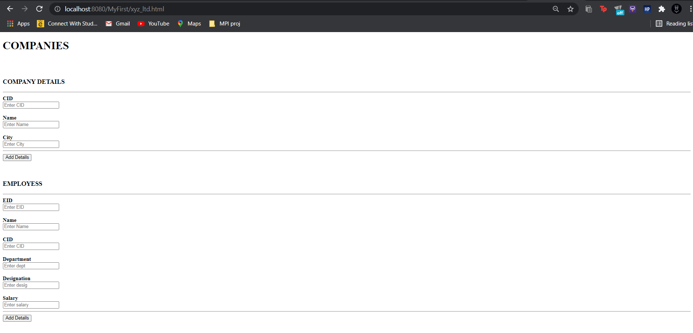

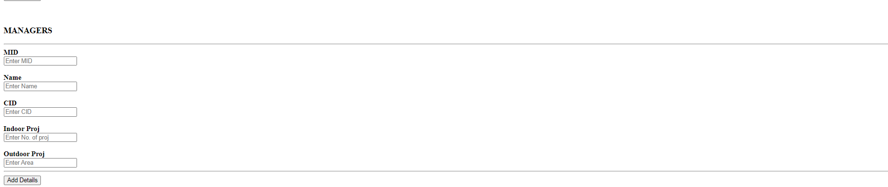

After adding details:

